

DEPARTMENT OF ARTIFICIAL INTELLIGENCE AND MACHINE LEARNING

AI23431 – WEB TECHNOLOGY AND MOBILE APPLICATION
(REGULATION 2023)
RAJALAKSHMI ENGINEERING COLLEGE
Thandalam, Chennai-602015

Name: SUPRAJA R
Register No: 231501164
Year / Branch / Section: 2nd / AIML / B
Semester: IV
Academic Year: 2024 - 2025

EX.NO: 1 | HTML - WEB PAGE TO EMBED A MAP ALONG WITH  HOTSPOT, FRAMES AND LINKS

PROGRAM:-

index.html
<!DOCTYPE html>
<html lang="en">
<head>
<meta charset="UTF-8">
<meta name="viewport" content="width=device-width, initial-scale=1.0">
<title>India Map</title>
<link rel="stylesheet" href="style.css">
</head>
<body>
<img src="india.png" alt="india_map" id="in_map" usemap="#in_map" >
<map name="in_map">
<area shape="rect" coords="191, 592, 242, 604" href="tn.html" alt="tamilnadu" target="_blank"> </map>
<a href="https://en.wikipedia.org/wiki/India">INDIA</a>
<iframe src="https://en.wikipedia.org/wiki/India" frameborder="0"></iframe>
</body>
</html>

tn.html

<!DOCTYPE html>
<html lang="en">
<head>
<meta charset="UTF-8">
<meta name="viewport" content="width=device-width, initial-scale=1.0">
<title>Tamil Nadu</title>
<style> #tn_map{ width: 500px; height: auto;
}
</style>
</head>
<body>
<h1>TAMIL NADU</h1>
<p>
Tamil Nadu is a southern state in India.
</p>
<img src="tamilnadu.png" alt="" id="tn_map">
</body>
</html>

OUTPUT:-

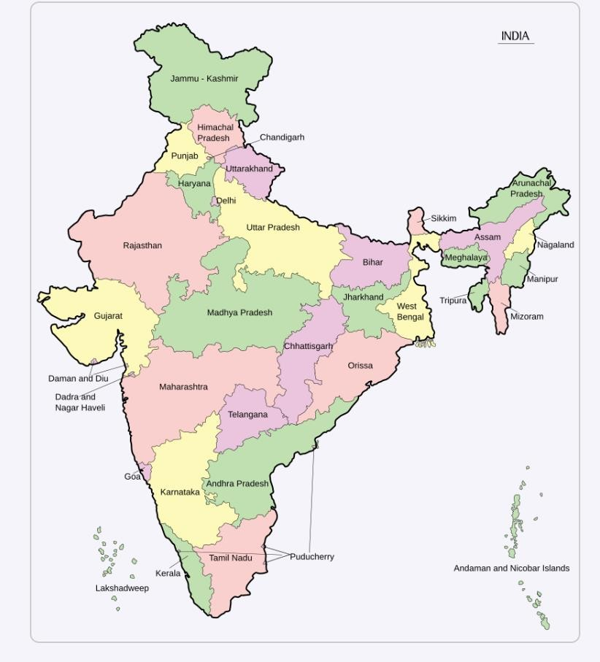

RESULT:-

Thus the given program is executed successfully and output is verified

EX.NO: 2 | CSS - WEB PAGE USING INTERNAL, EXTERNAL AND  INLINE CSS

PROGRAM:-

index.html
<!DOCTYPE html>
<html lang="en">
<head>
<meta charset="UTF-8">
<meta name="viewport" content="width=device-width, initial-scale=1.0">
<title>WT_EX.2</title>
<style>
.internal{ background-color: aquamarine; color: brown;
}
#p2{ width: 400px; height: auto;
}
</style>
<link rel="stylesheet" href="style.css">
</head>
<body>
<p style="background-color:black;">
<h1 style="color: blue; background-color:burlywood;">Inline CSS</h1>
<img src="P1.jpg" alt="img1" style="width: 400px; height:auto;">
</p>
<p>
<h1 class="internal">Internal CSS</h1>
<img src="P2.jpg" alt="" id="p2">
</p>
<p>
<h1 class="external">External CSS</h1>
<img src="P3.jpg" alt="" id="p3">
</p>
</body> </html> style.css

.external{ background-color:blueviolet; color:antiquewhite;
}
#p3{ width: 400px; height: auto;
}

OUTPUT:-

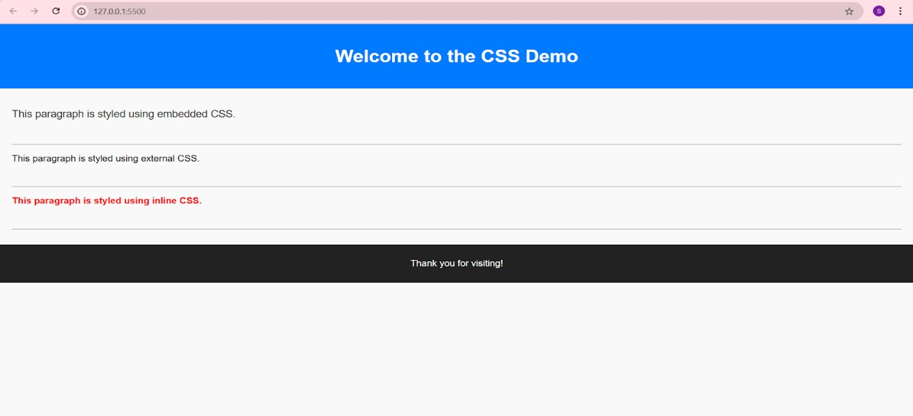

RESULT:-

Thus the given program is executed successfully and output is verified
EX.NO: 3 | JAVASCRIPT TO VALIDATE REGISTRATION FORM

PROGRAM:-

index.html

<!DOCTYPE html>
<html lang="en">
<head>
<meta charset="UTF-8">
<meta name="viewport" content="width=device-width, initial-scale=1.0">
<title>Registration form</title>
</head>
<body>
<script> function validateForm(){ const name=document.getElementById("fname").value; const fn_error=document.getElementById("fn_error"); const alphabets = /^[A-Za-z]+$/;

const password=document.getElementById("pswd").value; const p_error=document.getElementById("p_error");

const email=document.getElementById("email").value; const email_error=document.getElementById("email_error"); const emailPattern = /^[a-zA-Z0-9._%+-]+@[a-zA-Z0-9.-]+\.[a-zA-Z]{2,}$/;

const mobile=document.getElementById("mob").value; const mob_error=document.getElementById("mob_error");

const lname=document.getElementById("lname").value; const ln_error=document.getElementById("ln_error"); const address=document.getElementById("adrs").value; const adrs_error=document.getElementById("adrs_error");

let isValid=true;

fn_error.innerHTML = ""; p_error.innerHTML = ""; email_error.innerHTML = ""; mob_error.innerHTML = ""; ln_error.innerHTML = ""; adrs_error.innerHTML = "";

if(name.length <6 ){ fn_error.innerHTML="Name must be at least 6 characters long."; isValid= false;
}
else if (!name.match(alphabets)) { fn_error.innerHTML = "Name must contain only alphabets."; isValid= false;
}

if(password.length<6){ p_error.innerHTML="Password must be at least 6 characters long."; isValid= false;
}

if(!email.match(emailPattern)){ email_error.innerHTML="Invalid format."; isValid=false;
}

if (mobile.length !== 10 || isNaN(mobile)) {

mob_error.innerHTML = "Mobile number must be exactly 10 digits."; isValid = false;
}

if(lname.trim()===""){
ln_error.innerHTML="Last Name cannot be empty."; isValid=false;
}

if(address.trim()===""){ adrs_error.innerHTML="Address cannot be empty."; isValid=false;
}
if(isValid){ alert("Submitted!"); return true;
} return false;
}
</script>
<h1 style="text-align: center;">Registration Form</h1>
<form action="" onsubmit="return validateForm()">
<label for="fname">First Name:</label>
<input type="text" id="fname" name="First name" placeholder="Name">
<span style="color: red;" id="fn_error"></span>
<br><br>

<label for="pswd">Password:</label>
<input type="text" id="pswd" name="Password" placeholder="Password">
<span style="color: red;" id="p_error"></span>
<br><br>
<label for="E-mail">E-mail:</label>
<input type="text" name="E-mail id" id="email" placeholder="E-mail">
<span style="color: red;" id="email_error"></span>
<br><br>
<label for="Mob.number">Mobile Number:</label>
<input type="number" name="Mobile number" id="mob" placeholder="Mobile Number">
<span style="color: red;" id="mob_error"></span>
<br><br>
<label for="lname">Last Name:</label>
<input type="text" name="Last Name" id="lname" placeholder="Last Name">
<span style="color: red;" id="ln_error"></span>
<br><br>

<label for="address">Address:</label>
<input type="text" name="Address" id="adrs" placeholder="Address">
<span style="color: red;" id="adrs_error"></span>
<br><br>
<button>Submit</button>
</form>
</body>
</html>

OUTPUT:-
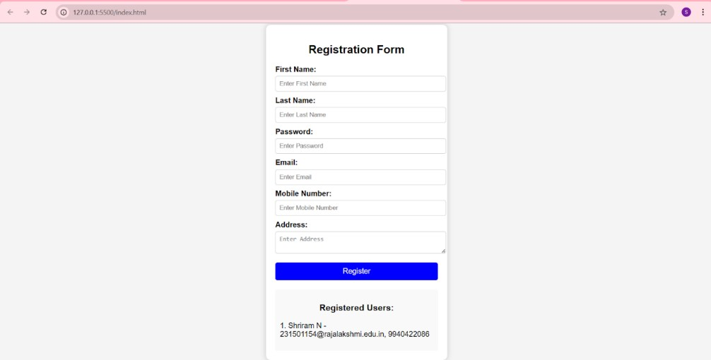

RESULT:-

Thus the given program is executed successfully and output is verified

EX.NO: 4 | SERVLET TO PRINT “Hello World!”

PROGRAM:-

HelloWorldServlet.java

import java.io.IOException; import java.io.PrintWriter; import javax.servlet.ServletException; import javax.servlet.annotation.WebServlet; import javax.servlet.http.HttpServlet; import javax.servlet.http.HttpServletRequest; import javax.servlet.http.HttpServletResponse;

@WebServlet("/hello") public class HelloWorldServlet extends HttpServlet { private static final long serialVersionUID = 1L;

@Override protected void doGet(HttpServletRequest request, HttpServletResponse response) throws ServletException, IOException { response.setContentType("text/html"); PrintWriter out = response.getWriter(); out.println("<html><body>"); out.println("<h1>Hello World</h1>"); out.println("</body></html>");
}
}

OUTPUT:-

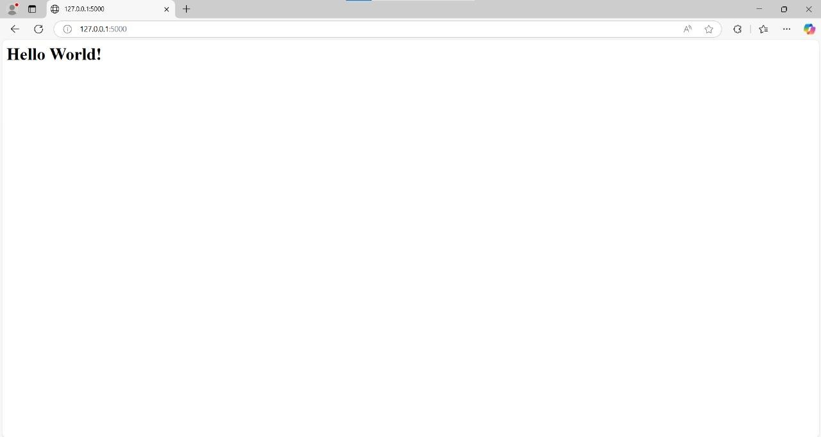

RESULT:-

Thus the given program is executed successfully and output is verified

EX.NO: 5 | SERVLET TO PROCESS FORM DATA AND DISPLAY  ON BROWSER

PROGRAM:-
FormServlet.java package com.example; import java.io.IOException; import javax.servlet.ServletException; import javax.servlet.annotation.WebServlet; import javax.servlet.http.HttpServlet; import javax.servlet.http.HttpServletRequest; import javax.servlet.http.HttpServletResponse;
@WebServlet("/form") public class FormServlet extends HttpServlet { protected void doPost(HttpServletRequest request, HttpServletResponse response) throws ServletException, IOException { String name = request.getParameter("name"); String email = request.getParameter("email"); response.setContentType("text/html"); response.getWriter().println("<h1>Form Submitted</h1>"); response.getWriter().println("<p>Name: " + name + "</p>"); response.getWriter().println("<p>Email: " + email + "</p>");
}
}

index.html <!DOCTYPE html>
<html>
<head>
<title>Form Example</title>
</head>
<body>
<h1>Submit Your Information</h1>
<form action="form" method="post">
<label for="name">Name:</label><br>
<input type="text" id="name" name="name"><br><br>
<label for="email">Email:</label><br>
<input type="email" id="email" name="email"><br><br>
<input type="submit" value="Submit">
</form>
</body>
</html>

OUTPUT:-
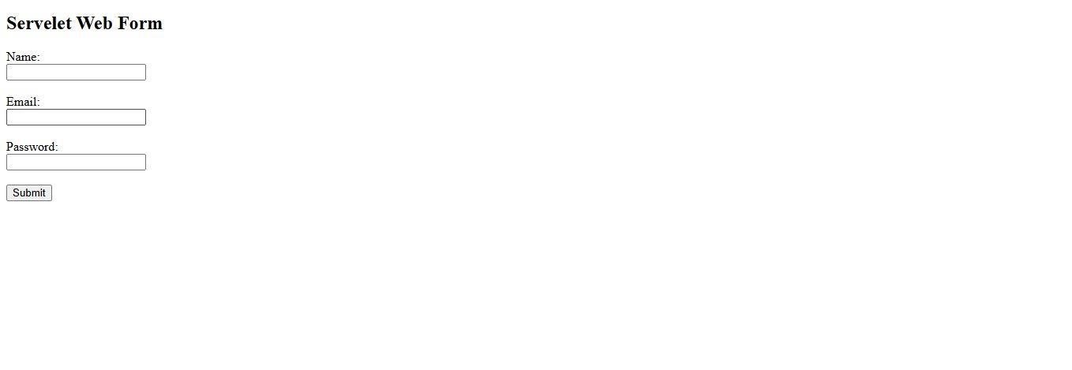

RESULT:-

Thus the given program is executed successfully and output is verified

EX.NO: 6 | SERVLET TO DIFFERENTIATE BETWEEN HTTP GET  AND POST

PROGRAM:-

Form.java
import java.io.IOException; import java.io.PrintWriter; import javax.servlet.ServletException; import javax.servlet.annotation.WebServlet; import javax.servlet.http.HttpServlet; import javax.servlet.http.HttpServletRequest; import javax.servlet.http.HttpServletResponse;

@WebServlet("/formDemo") public class Form2 extends HttpServlet { private static final long serialVersionUID = 1L;

protected void doGet(HttpServletRequest request, HttpServletResponse response) throws ServletException, IOException { response.setContentType("text/html"); PrintWriter out = response.getWriter();

// Handle GET request
String name = request.getParameter("name"); if (name != null) { out.println("<h3>You submitted via GET: " + name + "</h3>");
}

out.close();
}

protected void doPost(HttpServletRequest request, HttpServletResponse response) throws ServletException, IOException { response.setContentType("text/html"); PrintWriter out = response.getWriter();

// Handle POST request
String name = request.getParameter("name"); if (name != null) {
out.println("<h3>You submitted via POST: " + name + "</h3>");
}

out.close();
}
}

index.html

<!DOCTYPE html>
<html lang="en">
<head>
<meta charset="UTF-8">
<meta name="viewport" content="width=device-width, initial-scale=1.0">
<title>Form Demo</title>
</head>
<body>
<h2>Submit Data Using GET Method</h2>
<form method="GET" action="formDemo">
Name: <input type="text" name="name"><br>
<input type="submit" value="Submit via GET">
</form>

<h2>Submit Data Using POST Method</h2>
<form method="POST" action="formDemo">
Name: <input type="text" name="name"><br>
<input type="submit" value="Submit via POST">
</form>
</body>
</html>

OUTPUT:-

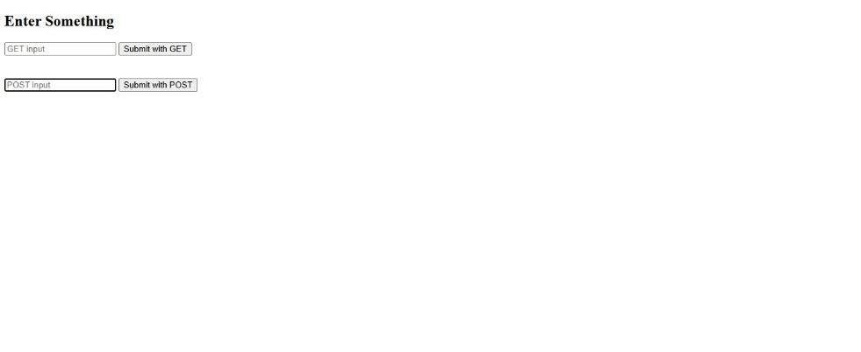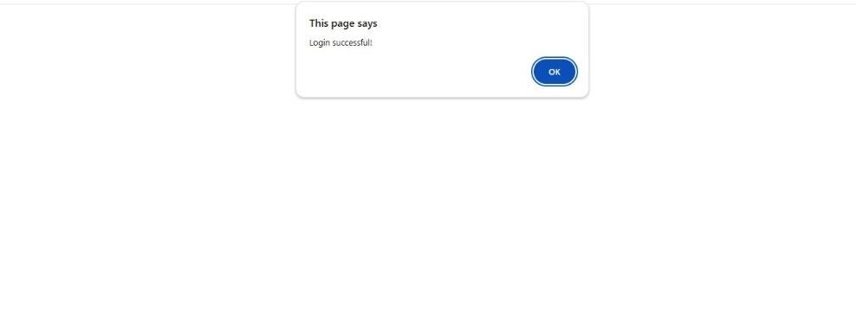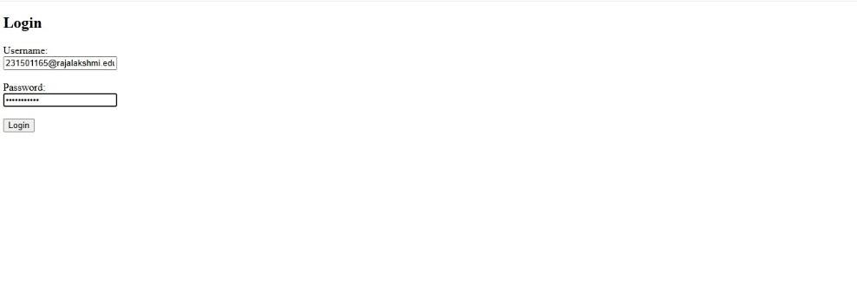

RESULT:-

Thus the given program is executed successfully and output is verified

EX.NO: 7 | SERVLET TO DEMONSTRATE SESSION TRACKING  USING HttpSession

PROGRAM:-

index.html
<!DOCTYPE html>
<html lang="en">
<head>
<meta charset="UTF-8">
<meta name="viewport" content="width=device-width, initial-scale=1.0">
<title>Login</title>
</head>
<body>
<h2>Login Form</h2>
<form action="login" method="post">
<label for="username">Username:</label>
<input type="text" id="username" name="username" required>
<br><br>
<label for="password">Password:</label>
<input type="password" id="password" name="password" required>
<br><br>
<input type="submit" value="Login">
</form>
</body>
</html>

LoginServlet.java import java.io.IOException; import javax.servlet.ServletException; import javax.servlet.annotation.WebServlet; import javax.servlet.http.HttpServlet;
import javax.servlet.http.HttpServletRequest; import javax.servlet.http.HttpServletResponse; import javax.servlet.http.HttpSession;
@WebServlet("/login")
public class LoginServlet extends HttpServlet { private static final long serialVersionUID = 1L;
protected void doPost(HttpServletRequest request, HttpServletResponse response) throws
ServletException, IOException {
String username = request.getParameter("username"); String password = request.getParameter("password"); if ("admin".equals(username) && "password".equals(password)) { HttpSession session = request.getSession(); session.setAttribute("username", username); response.sendRedirect("welcome.jsp");
} else { response.sendRedirect("index.html?error=Invalid credentials");
}
}
}
LogoutServlet.java import java.io.IOException; import javax.servlet.ServletException; import javax.servlet.annotation.WebServlet; import javax.servlet.http.HttpServlet; import javax.servlet.http.HttpServletRequest; import javax.servlet.http.HttpServletResponse; import javax.servlet.http.HttpSession;
@WebServlet("/logout") public class LogoutServlet extends HttpServlet { private static final long serialVersionUID = 1L;

protected void doGet(HttpServletRequest request, HttpServletResponse response) throws
ServletException, IOException {
HttpSession session = request.getSession(false);
if (session != null) { session.invalidate();
}
response.sendRedirect("index.html");
}
}

OUTPUT:-
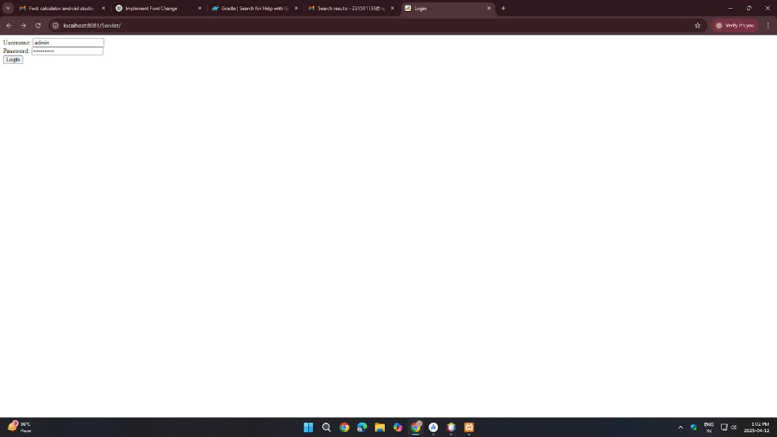

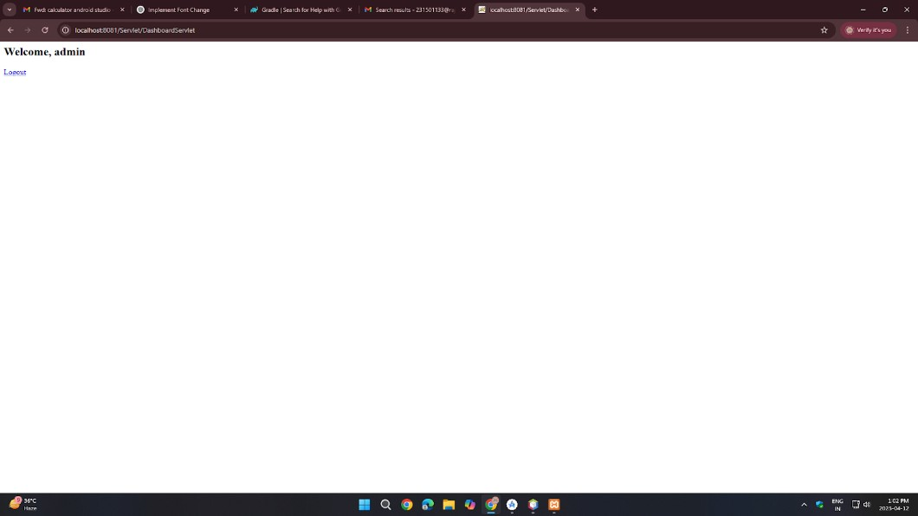

RESULT:-

Thus the given program is executed successfully and output is verified

EX.NO: 8 | ANDROID APPLICATION - BASIC CALCULATOR

PROGRAM:-

MainActivity.kt

package com.example.calculatorapp import androidx.appcompat.app.AppCompatActivity import android.os.Bundle import android.widget.*

class MainActivity : AppCompatActivity() { lateinit var num1: EditText lateinit var num2: EditText lateinit var resultView: TextView lateinit var addBtn: Button lateinit var subBtn: Button lateinit var mulBtn: Button lateinit var divBtn: Button

override fun onCreate(savedInstanceState: Bundle?) { super.onCreate(savedInstanceState) setContentView(R.layout.activity_main)

num1 = findViewById(R.id.num1) num2 = findViewById(R.id.num2) resultView = findViewById(R.id.resultView) addBtn = findViewById(R.id.addBtn) subBtn = findViewById(R.id.subBtn) mulBtn = findViewById(R.id.mulBtn) divBtn = findViewById(R.id.divBtn)

addBtn.setOnClickListener { calculate('+') } subBtn.setOnClickListener { calculate('-') } mulBtn.setOnClickListener { calculate('*') } divBtn.setOnClickListener { calculate('/') }
}

private fun calculate(operator: Char) { val input1 = num1.text.toString() val input2 = num2.text.toString()

if (input1.isEmpty() || input2.isEmpty()) { resultView.text = "Please enter both numbers." return
}

val a = input1.toDouble() val b = input2.toDouble() val result = when (operator) {
'+' -> a + b
'-' -> a - b
'*' -> a * b '/' -> { if (b == 0.0) { resultView.text = "Cannot divide by zero." return } else a / b } else -> 0.0
}

resultView.text = "Result: $result"
}
}

activity_main.xml

<?xml version="1.0" encoding="utf-8"?>
<LinearLayout
xmlns:android="http://schemas.android.com/apk/res/android" android:layout_width="match_parent" android:layout_height="match_parent" android:orientation="vertical" android:padding="20dp">

<EditText android:id="@+id/num1" android:layout_width="match_parent" android:layout_height="wrap_content" android:hint="Enter first number" android:inputType="numberDecimal"/>

<EditText android:id="@+id/num2" android:layout_width="match_parent" android:layout_height="wrap_content" android:hint="Enter second number" android:inputType="numberDecimal"/>

<LinearLayout
android:layout_width="match_parent" android:layout_height="wrap_content" android:orientation="horizontal" android:gravity="center" android:layout_marginTop="20dp">

<Button android:id="@+id/addBtn" android:layout_width="wrap_content" android:layout_height="wrap_content" android:text="+" />

<Button android:id="@+id/subBtn" android:layout_width="wrap_content" android:layout_height="wrap_content" android:text="-" />

<Button android:id="@+id/mulBtn" android:layout_width="wrap_content" android:layout_height="wrap_content" android:text="×" />

<Button android:id="@+id/divBtn" android:layout_width="wrap_content" android:layout_height="wrap_content" android:text="÷" />
</LinearLayout>

<TextView android:id="@+id/resultView" android:layout_width="match_parent" android:layout_height="wrap_content" android:text="Result will be shown here" android:textSize="18sp" android:layout_marginTop="30dp"/>
</LinearLayout>

OUTPUT:-

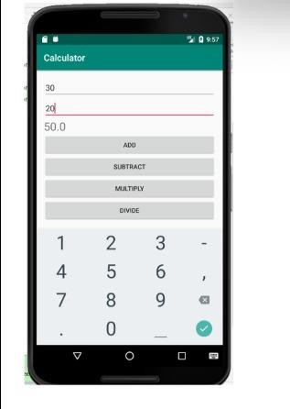

RESULT:-

Thus the given program is executed successfully and output is verified

EX.NO: 10 | ANDROID APPLICATION TO CHANGE FONT AND  COLOR OF TEXT

PROGRAM:-

MainActivity.kt

package com.example.fontchange

import android.graphics.Typeface import android.os.Bundle import android.widget.Button import android.widget.TextView import android.widget.Toast import androidx.activity.ComponentActivity import androidx.core.content.ContextCompat

class MainActivity : ComponentActivity() {

private lateinit var textView: TextView private lateinit var buttonChange: Button

override fun onCreate(savedInstanceState: Bundle?) { super.onCreate(savedInstanceState) setContentView(R.layout.activity_main) textView = findViewById(R.id.textView) buttonChange = findViewById(R.id.buttonChange) buttonChange.setOnClickListener { changeTextStyle() showToastMessage()
} }

private fun changeTextStyle() {
textView.typeface = Typeface.create("sans-serif-medium", Typeface.NORMAL) textView.setTextColor(ContextCompat.getColor(this, android.R.color.holo_blue_light)) }

private fun showToastMessage() {
Toast.makeText(this, "Text style changed!", Toast.LENGTH_SHORT).show()
}

} activity_main.xml

<?xml version="1.0" encoding="utf-8"?>
<RelativeLayout xmlns:android="http://schemas.android.com/apk/res/android&quot; android:layout_width="match_parent" android:layout_height="match_parent">

<TextView android:id="@+id/textView" android:layout_width="wrap_content" android:layout_height="wrap_content" android:text="Hello, World!" android:textSize="24sp" android:layout_centerInParent="true" android:textColor="@android:color/black”/>

<Button android:id="@+id/buttonChange" android:layout_width="wrap_content" android:layout_height="wrap_content" android:text="Change Font and Color" android:layout_below="@id/textView" android:layout_centerHorizontal="true" android:layout_marginTop="20dp”/>
</RelativeLayout>

OUTPUT:-

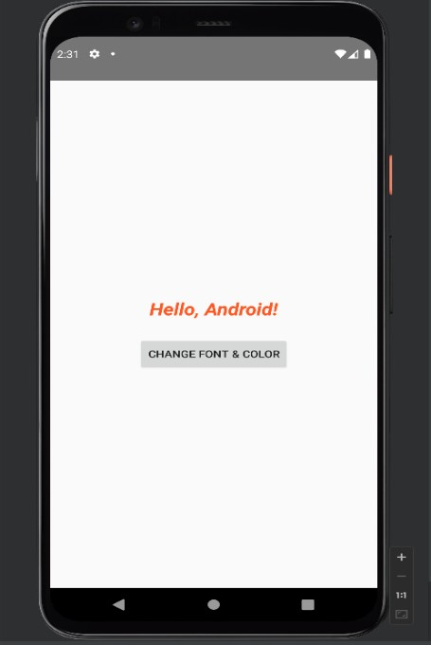

RESULT:-

Thus the given program is executed successfully and output is verified

EX.NO: 10 | ANDROID APPLICATION - SD CARD WRITER

PROGRAM:-

MainActivity.kt

package com.example.sdcard

import android.content.ContentValues import android.net.Uri import android.os.Bundle import android.provider.MediaStore import android.widget.Button import android.widget.Toast import androidx.activity.ComponentActivity

class MainActivity : ComponentActivity() {

override fun onCreate(savedInstanceState: Bundle?) { super.onCreate(savedInstanceState) setContentView(R.layout.activity_main)

val writeButton = findViewById<Button>(R.id.buttonWrite)

writeButton.setOnClickListener { writeToExternalStorage("Hello World!")
}
}

private fun writeToExternalStorage(data: String) { val values = ContentValues().apply { put(MediaStore.Files.FileColumns.DISPLAY_NAME, "sample.txt") put(MediaStore.Files.FileColumns.MIME_TYPE, "text/plain")
put(MediaStore.Files.FileColumns.RELATIVE_PATH, "Documents/MyAppFolder")
}

val uri: Uri? = contentResolver.insert(MediaStore.Files.getContentUri("external"), values)
uri?.let { try {
val outputStream = contentResolver.openOutputStream(it) outputStream?.write(data.toByteArray()) outputStream?.close()
Toast.makeText(this, "Data written to $it", Toast.LENGTH_LONG).show()
} catch (e: Exception) {
Toast.makeText(this, "Error: ${e.message}", Toast.LENGTH_LONG).show()
}
} ?: run {
Toast.makeText(this, "Error creating file", Toast.LENGTH_LONG).show()
}
}
}

activity_main.xml

<?xml version="1.0" encoding="utf-8"?>
<LinearLayout
xmlns:android="http://schemas.android.com/apk/res/android" android:orientation="vertical" android:layout_width="match_parent" android:layout_height="match_parent" android:gravity="center" android:padding="16dp">

<Button android:id="@+id/buttonWrite" android:layout_width="wrap_content" android:layout_height="wrap_content" android:text="Write to SD Card" />
</LinearLayout>

OUTPUT:-

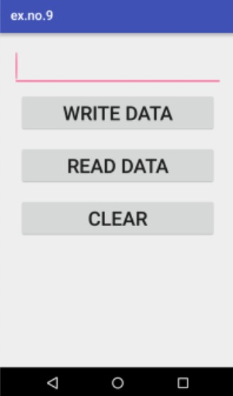

RESULT:-

Thus the given program is executed successfully and output is verified

